~Asia-Japan-Mirror-Dragon with open maw-Edo

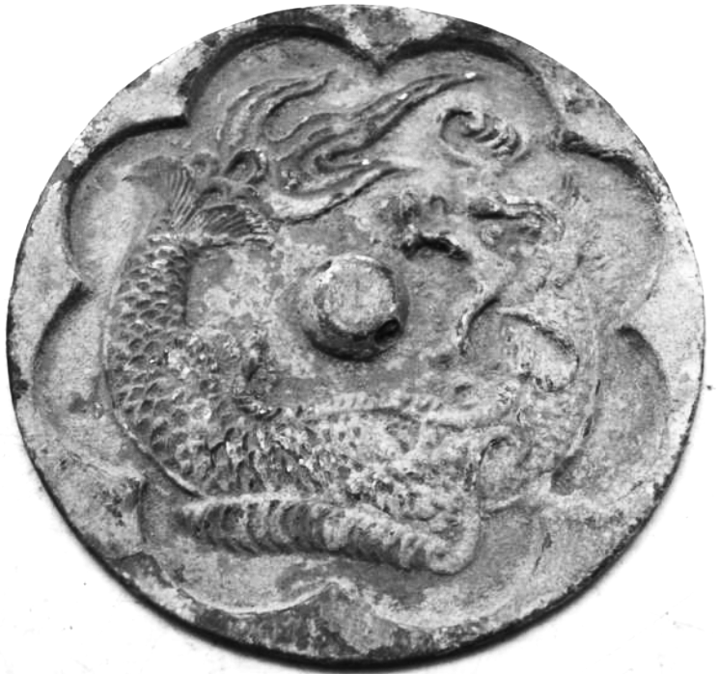

Japanese bronze mirror measuring 125mm in diameter.  This bronze mirror has a lovely aged verdigris patina and is very well handled & rubbed.  It is ornamented on the back with an oriental creature or dragon and what appears to be a buddha.  It has a central boss which is pierced to allow a cord to be passed through for holding.  The other side is undecorated and would have originally been more highly polished to create a reflective surface.